**COMP30660** **-** **Computer** **Arch** **&** **Org** **(Conv)** **-2022/23**

**Assignment** **1:** **Number** **System** **and** **Logic**

**[15** **Points]**

Student Name: Wenqing Zhao

Student Number: 21211886

1. Conversion

a. Complete this summation by converting the decimal numbers to binary by using Double Dabble Method and then converting the result of the sum back to decimal (Show the steps to get full marks) [1 Point]

105 ???? ????

114 ???? ????

??? ???? ????

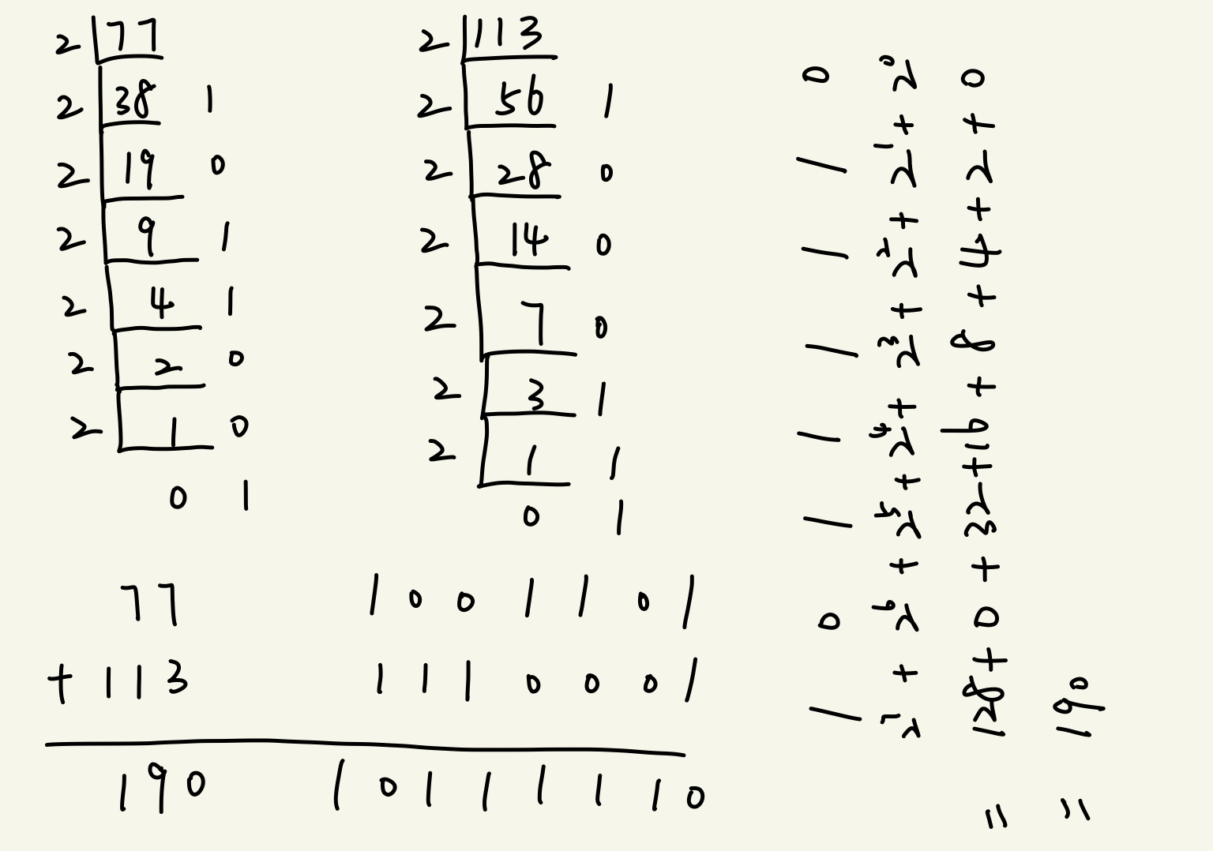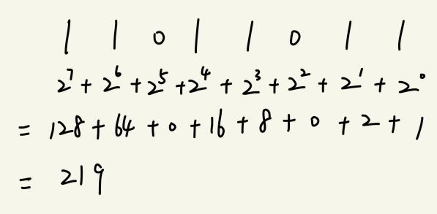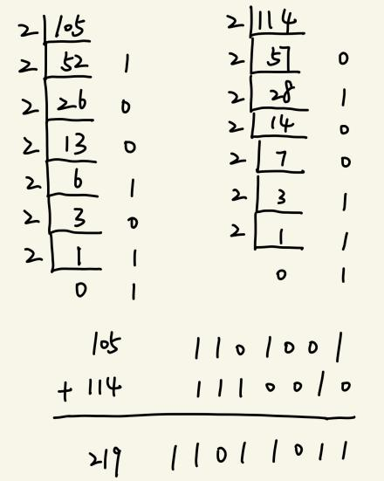b. Complete this summation by converting the decimal numbers to octal by using Direct Method and then converting the result of the sum back to decimal (Show the steps to get full marks) [1 Point]

77 ???? ????

113 ???? ????

??? ???? ????

2. Represent following decimal numbers using, 8-bit Signed magnitude binary representation, 8 bits Signed 1’s complement binary representation and 8 bit Signed 2’s complement binary representation [1 Point]

a) 41

b) -41

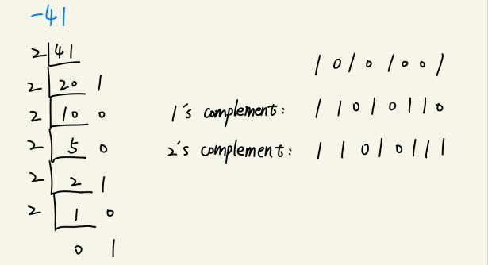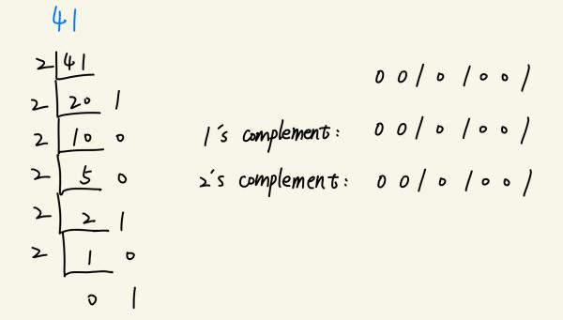c) 32

d) -32

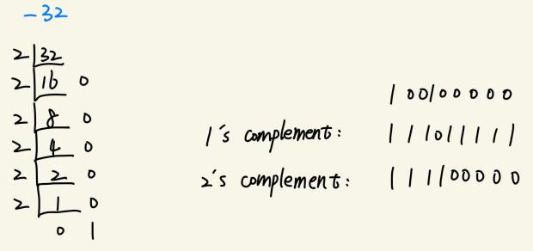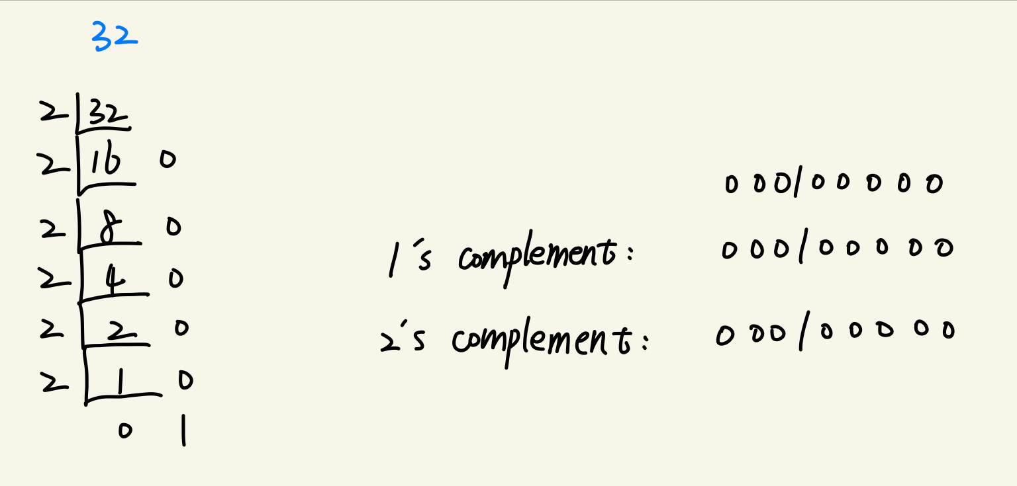

e) 101

f) -71

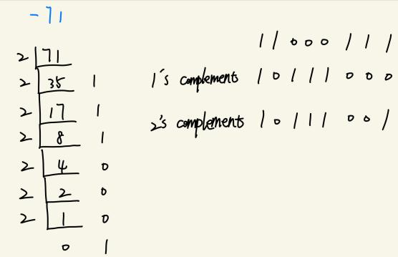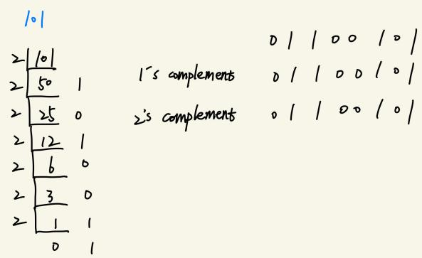

g) 27 out of range, so it doesn’t has 1’s complement and 2’s complement.

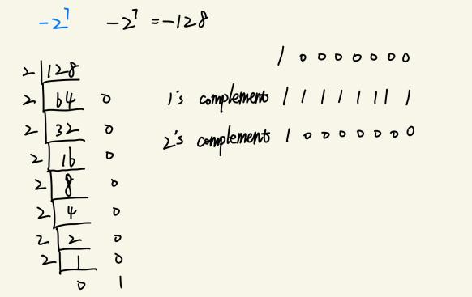h) -27

3. Convert the following numbers with the indicated bases into decimal [1 Point]

a. (23410)5

b. (645213)7

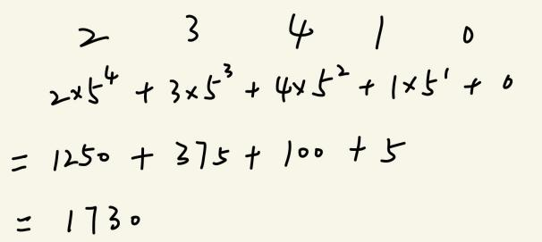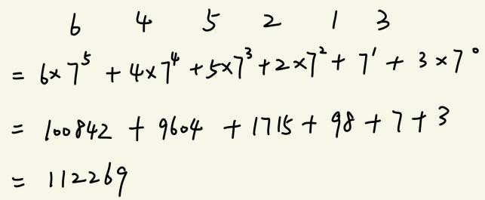

c. (856125)9

d. (B24AC)16

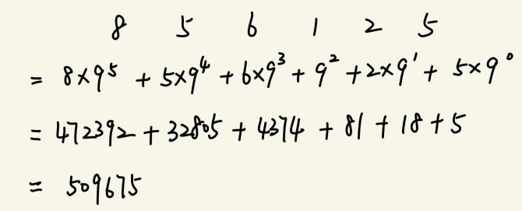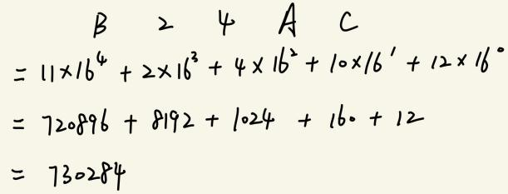

4. Add the following binary numbers [1 Point]

a. 10101.10101 + 111.1101

b. 1010.10011 + 0.1101

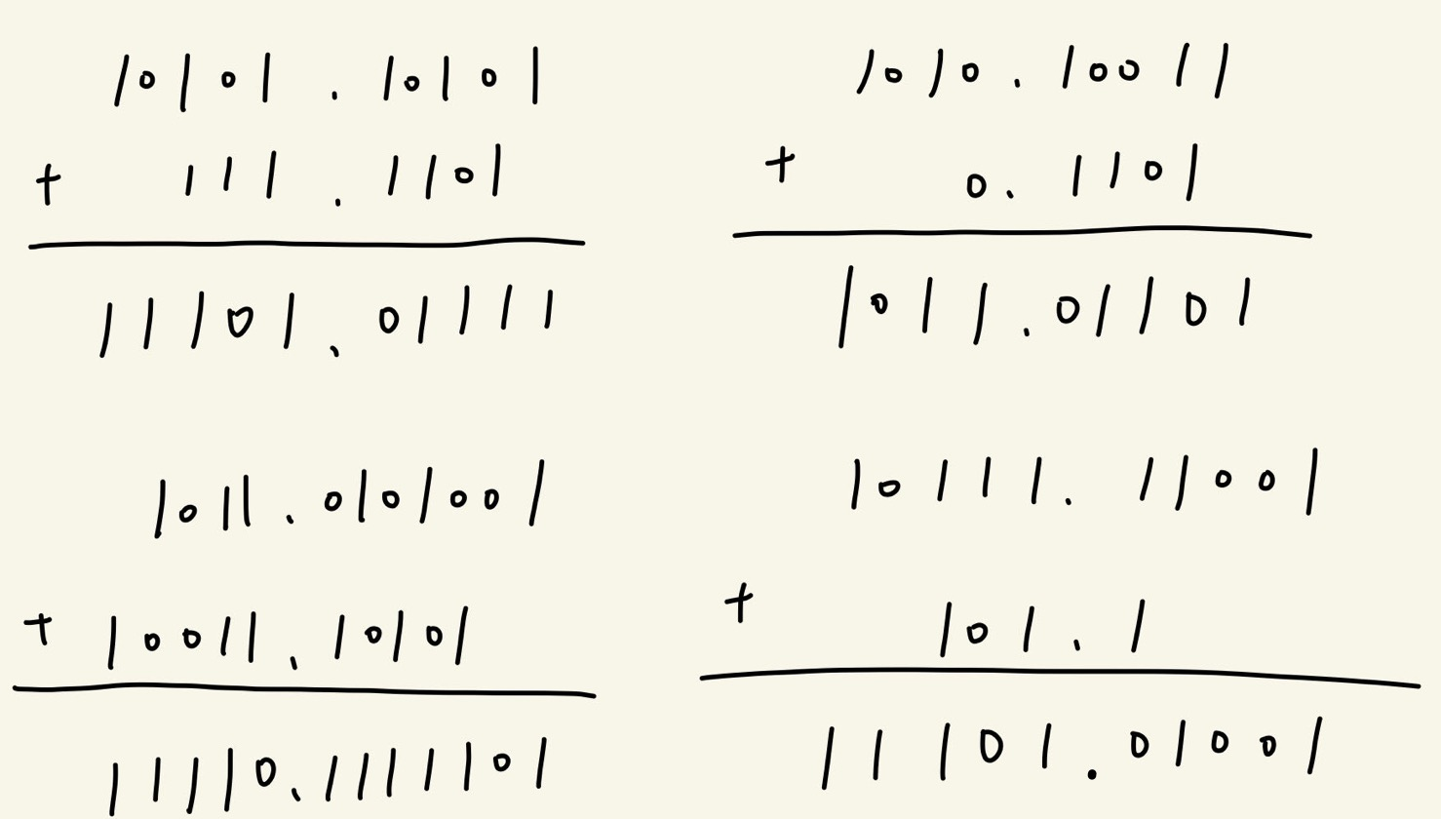

c. 1011.0101001 + 10011.10101

d. 10111.11001 + 101.1



5. Perform the following operations. (Note: Please consider the base) [1 Point]

a. (A914)16 + (BC12A)16

b. (E189A)16 + (BB87A)16

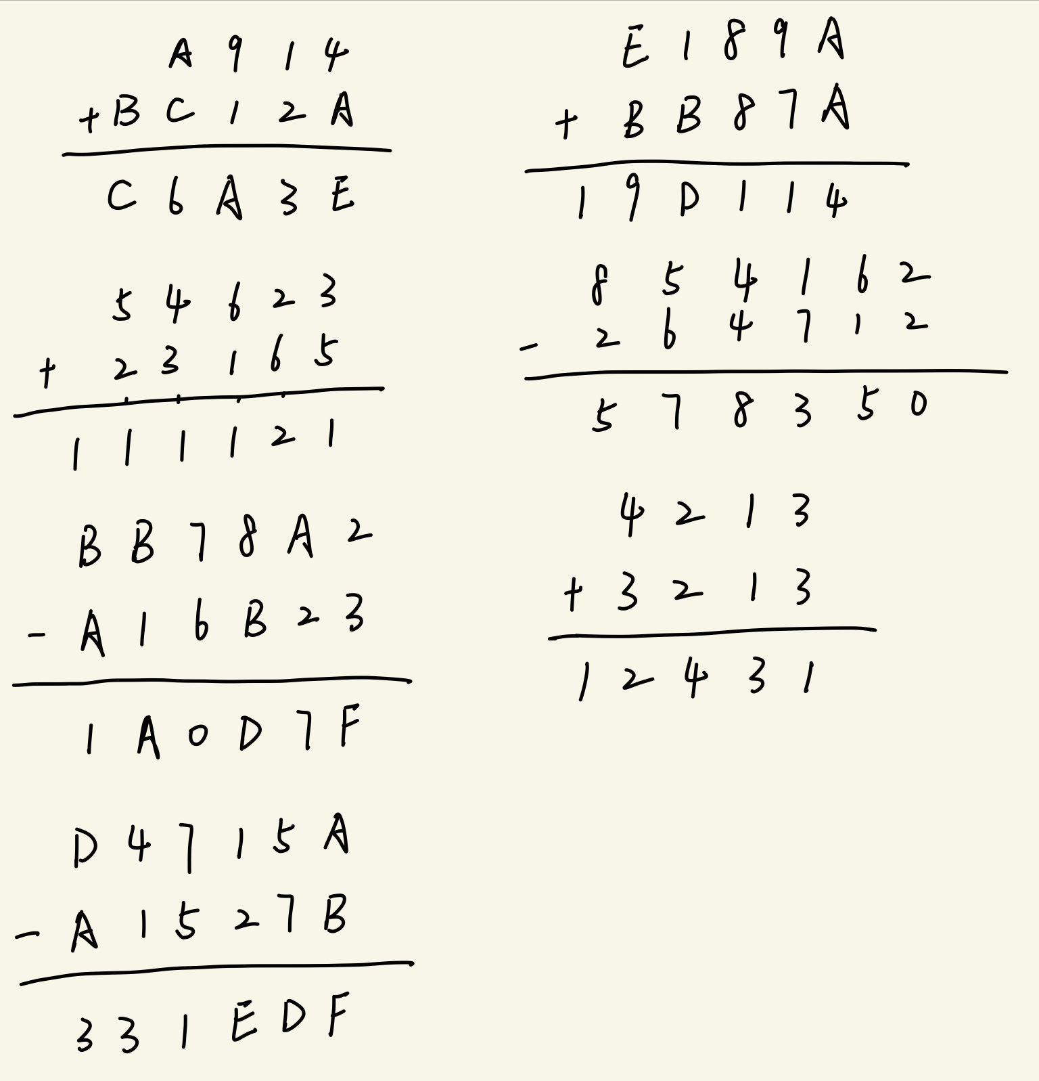

c. (54623)7 + (23165)7

d. (854162)9 - (264712)9



e. (BB78A2)16 – (A16B23)16

f. (4213)5 + (3213)5



g. (D4715A)16 – (A1527B)16



6. Logic Circuits

A. Write the Boolean equations for each of the logic circuits shown below [0.5 Point]

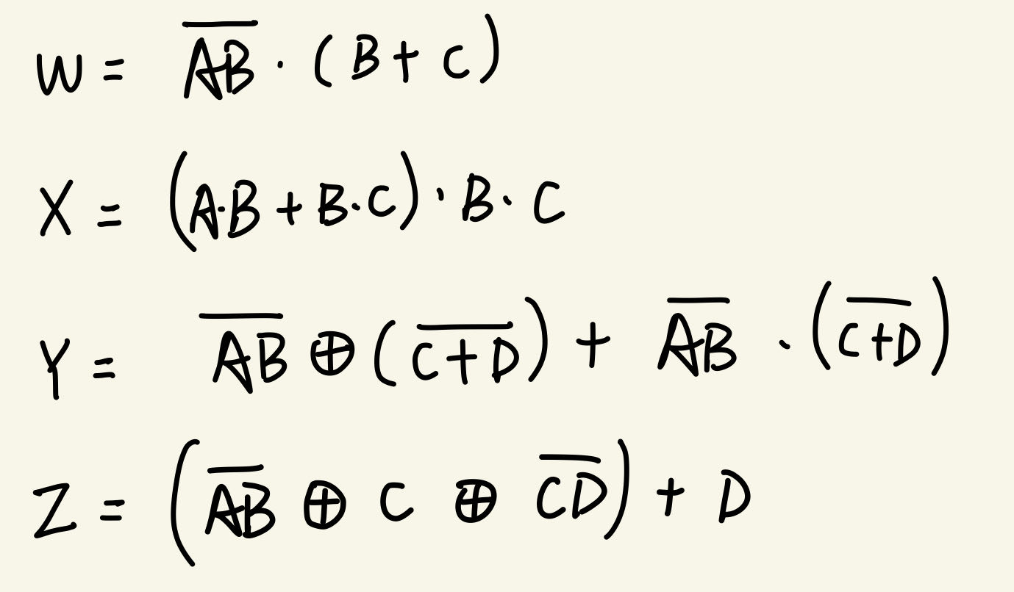

1. Create the truth table for each circuit[1 Point]

**(a)**

|  |  |  |  |
| --- | --- | --- | --- |
| A | B | C | W |
| 0 | 0 | 0 | 0 |
| 1 | 0 | 0 | 0 |
| 0 | 1 | 0 | 1 |
| 0 | 0 | 1 | 1 |
| 1 | 1 | 0 | 0 |
| 1 | 0 | 1 | 1 |
| 0 | 1 | 1 | 1 |
| 1 | 1 | 1 | 0 |

**(b)**

|  |  |  |  |
| --- | --- | --- | --- |
| A | B | C | X |
| 0 | 0 | 0 | 0 |
| 1 | 0 | 0 | 0 |
| 0 | 1 | 0 | 0 |
| 0 | 0 | 1 | 0 |
| 1 | 1 | 0 | 0 |
| 1 | 0 | 1 | 0 |
| 0 | 1 | 1 | 1 |
| 1 | 1 | 1 | 1 |

**(c)**

|  |  |  |  |  |
| --- | --- | --- | --- | --- |
| A | B | C | D | Y |
| 0 | 0 | 0 | 0 | 1 |
| 1 | 0 | 0 | 0 | 1 |
| 0 | 1 | 0 | 0 | 1 |
| 0 | 0 | 1 | 0 | 1 |
| 0 | 0 | 0 | 1 | 1 |
| 1 | 1 | 0 | 0 | 1 |
| 0 | 1 | 1 | 0 | 1 |
| 0 | 0 | 1 | 1 | 1 |
| 1 | 0 | 1 | 0 | 1 |
| 0 | 1 | 0 | 1 | 1 |
| 1 | 0 | 0 | 1 | 1 |
| 1 | 1 | 1 | 0 | 0 |
| 0 | 1 | 1 | 1 | 1 |
| 1 | 0 | 1 | 1 | 1 |
| 1 | 1 | 0 | 1 | 0 |
| 1 | 1 | 1 | 1 | 0 |

**(d)**

|  |  |  |  |  |
| --- | --- | --- | --- | --- |
| A | B | C | D | Z |
| 0 | 0 | 0 | 0 | 0 |
| 1 | 0 | 0 | 0 | 0 |
| 0 | 1 | 0 | 0 | 0 |
| 0 | 0 | 1 | 0 | 1 |
| 0 | 0 | 0 | 1 | 1 |
| 1 | 1 | 0 | 0 | 1 |
| 0 | 1 | 1 | 0 | 1 |
| 0 | 0 | 1 | 1 | 1 |
| 1 | 0 | 1 | 0 | 1 |
| 0 | 1 | 0 | 1 | 1 |
| 1 | 0 | 0 | 1 | 1 |
| 1 | 1 | 1 | 0 | 0 |
| 0 | 1 | 1 | 1 | 1 |
| 1 | 0 | 1 | 1 | 1 |
| 1 | 1 | 0 | 1 | 1 |
| 1 | 1 | 1 | 1 | 1 |

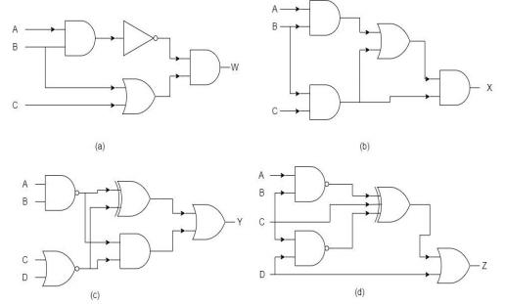

7.

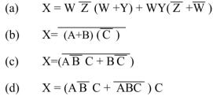

1. Draw the logic circuit diagram for the Boolean equations above [1 Point]

**(a)**

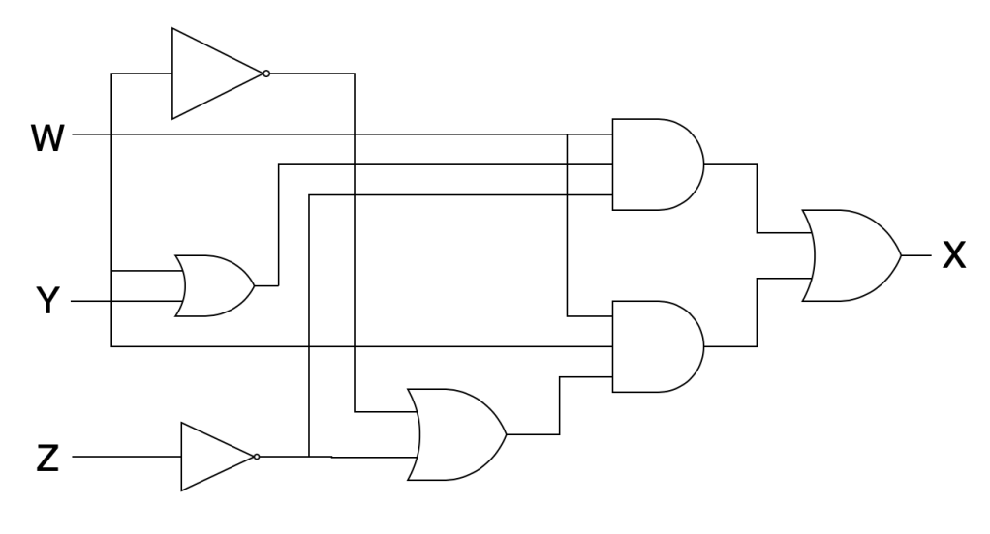

**(b)**

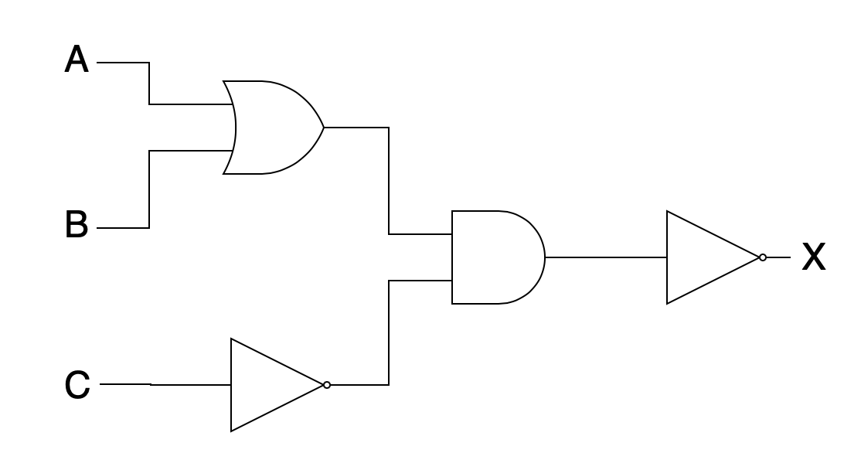

**(c)**

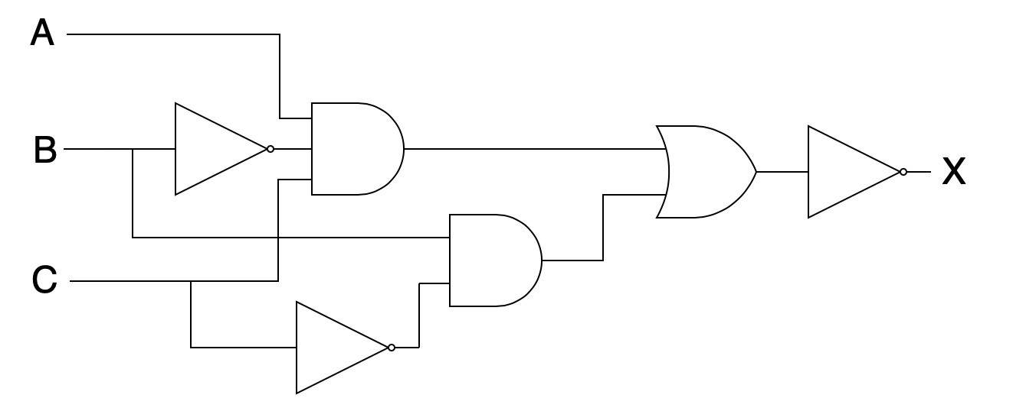

**(d)**

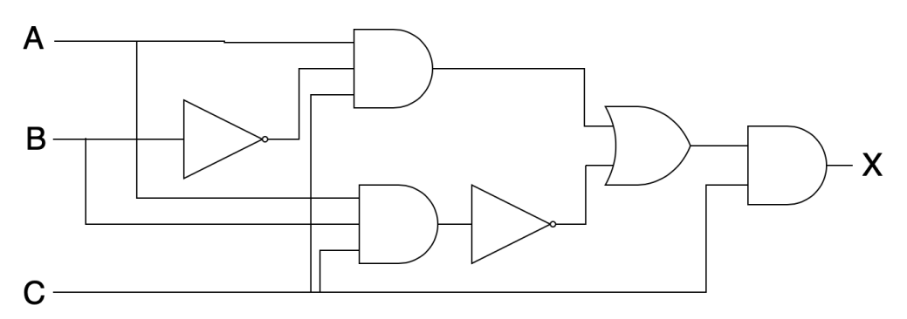

b. Using the DeMorgan’s Theorem and Boolean Laws and Rules, simplify and reduce to the stage where the overbars are above a single variable only [1 Point]

**(a)**

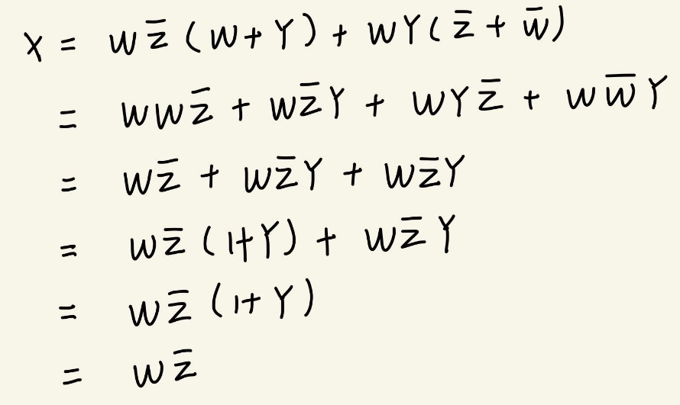

**(b)**

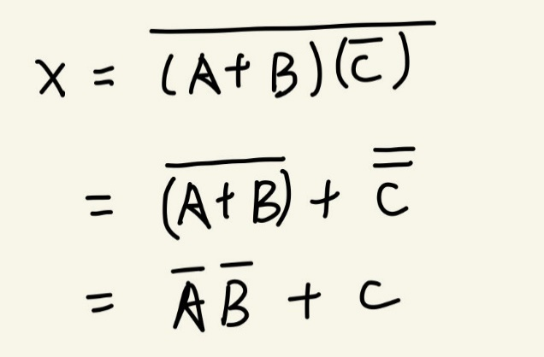

**(c)**

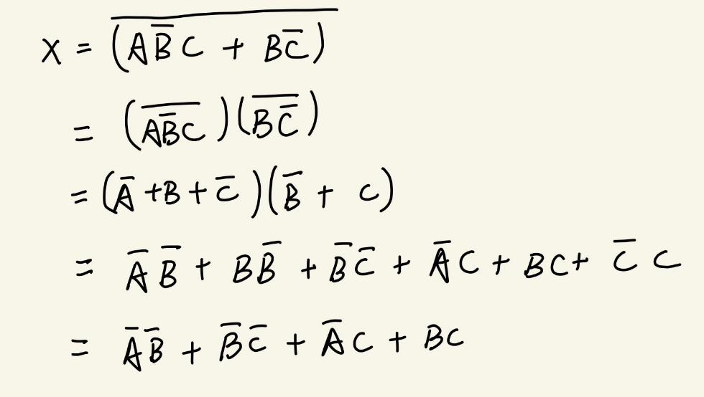

**(d)**

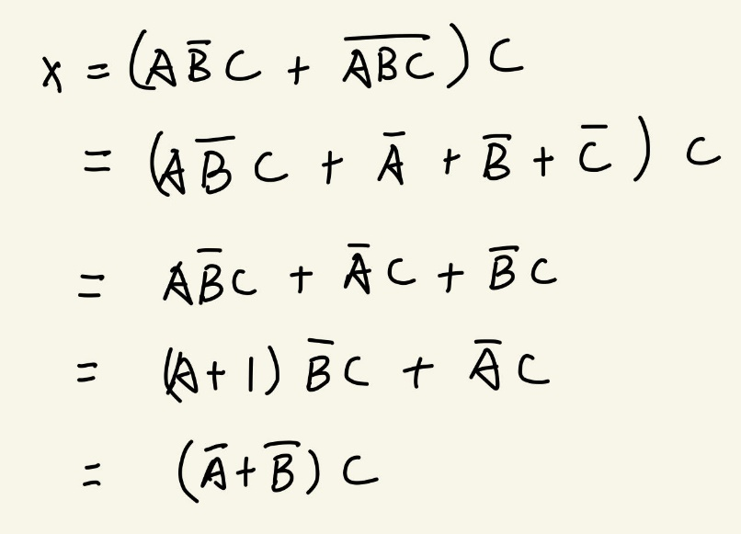

c. Draw the simplified circuit [0.5 Point]

**(a)**

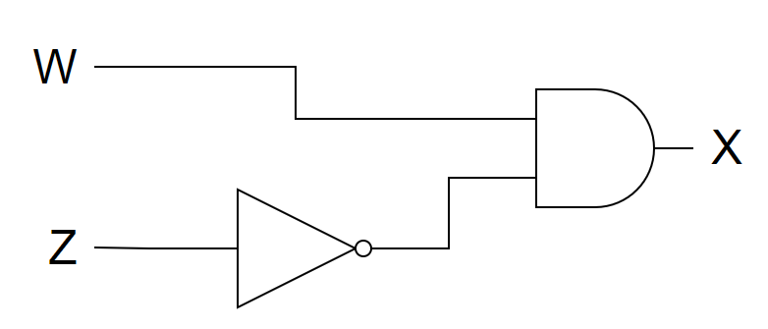

**(b)**

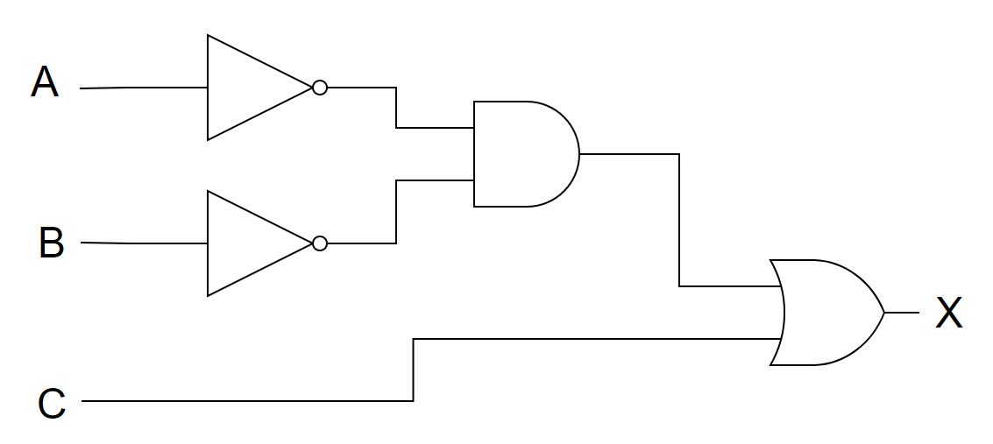

**(c)**

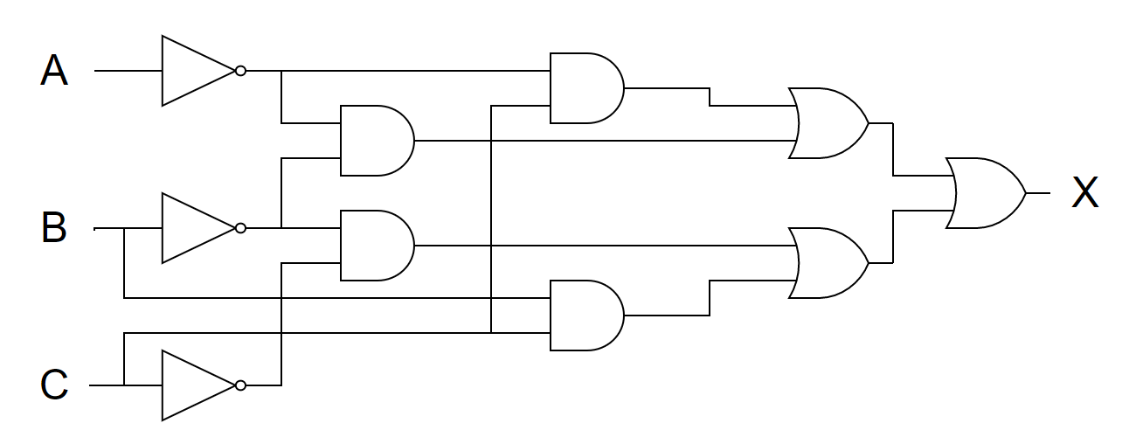

**(d)**

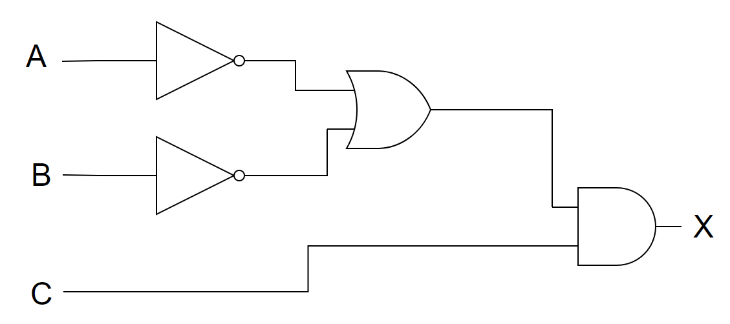

1. a) Draw half adder and full adder circuits [0.5 points]

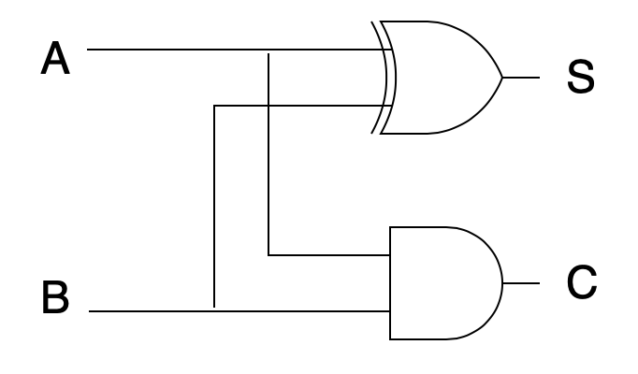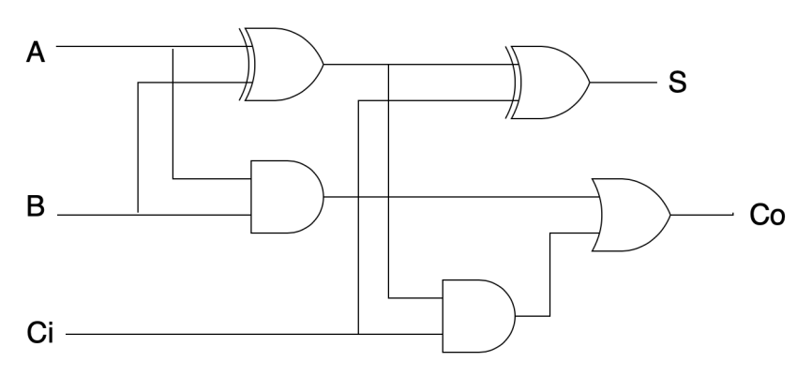

b) Draw them only using NAND gates [0.5 points]

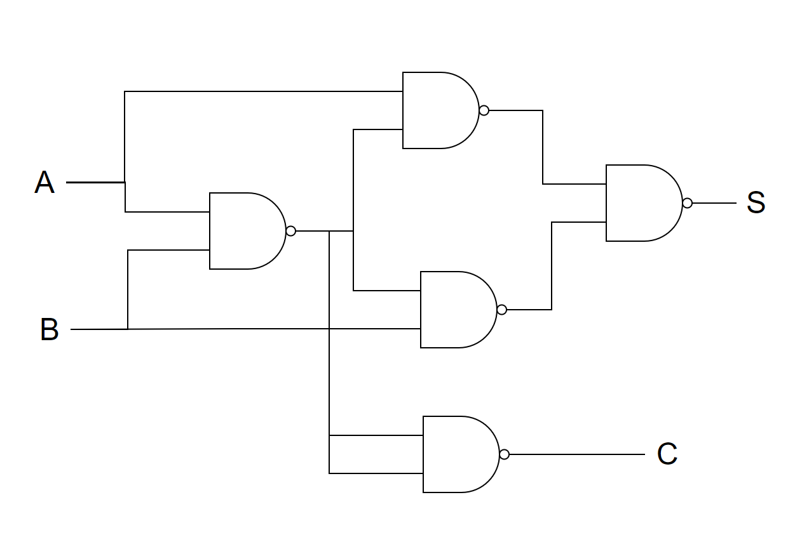

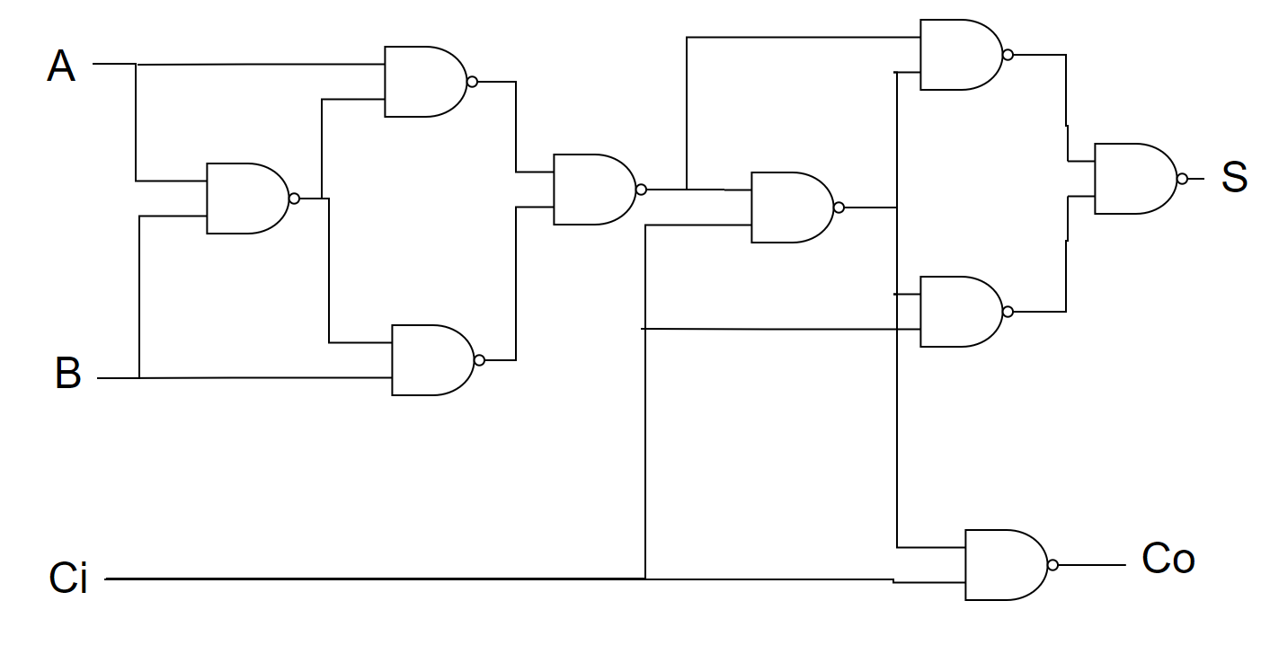

c) Draw them only using NOR gates [1 point]

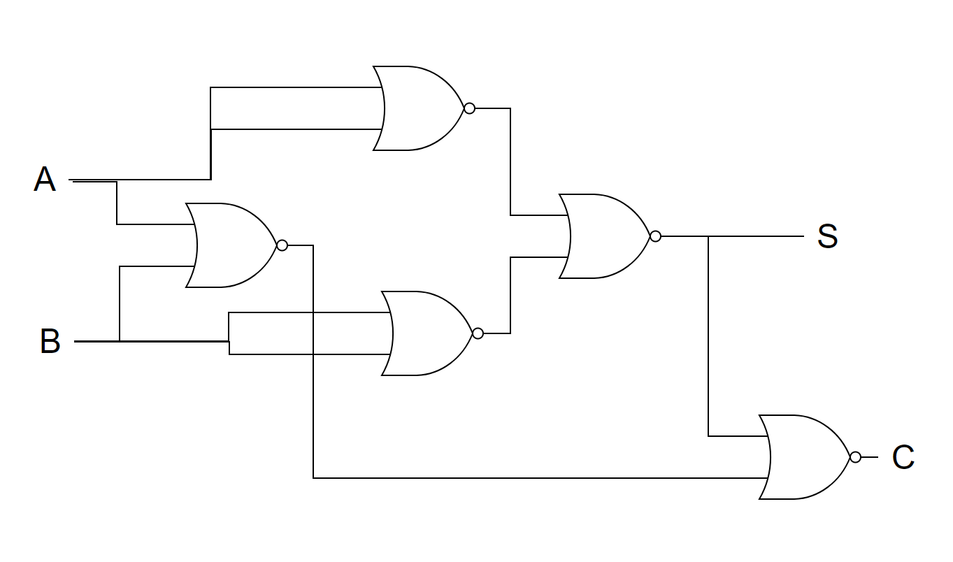

9. Determine which rule (or rules) are being used in the following Boolean reductions and show the steps of reduction [2 Points]

̅̅̅ = x.  + Y. 

̅̅̅̅̅̅̅ = x + Y)

AB + AC + ABC = A(B + C)

AB + A( + C) + AB  = A

(A + B)(A + C) = A + BC

(A +  + )(A +  + C)(A + B + ) = A + 

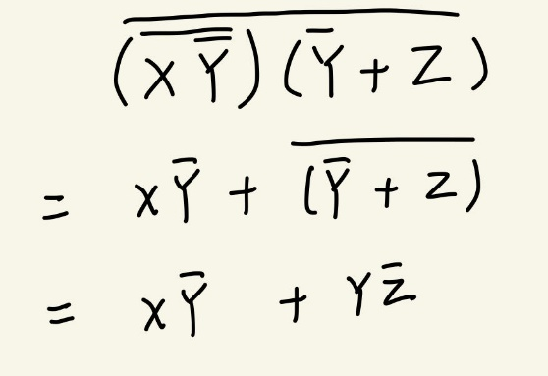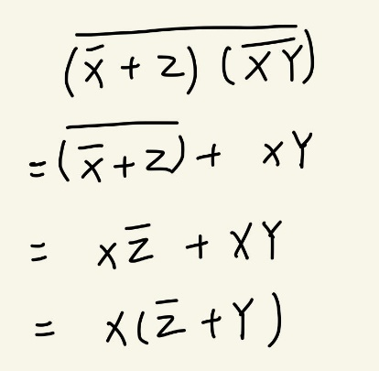

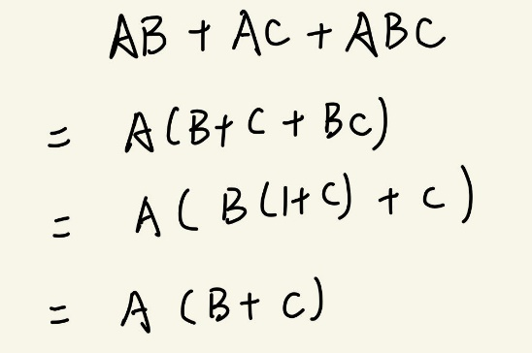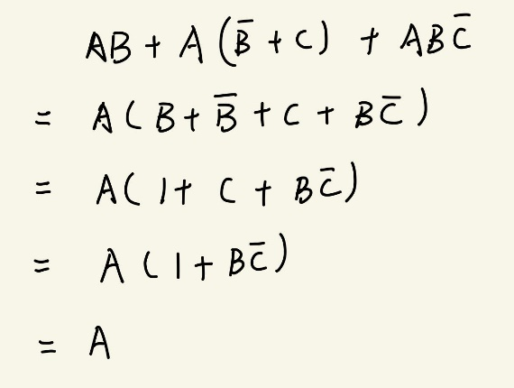

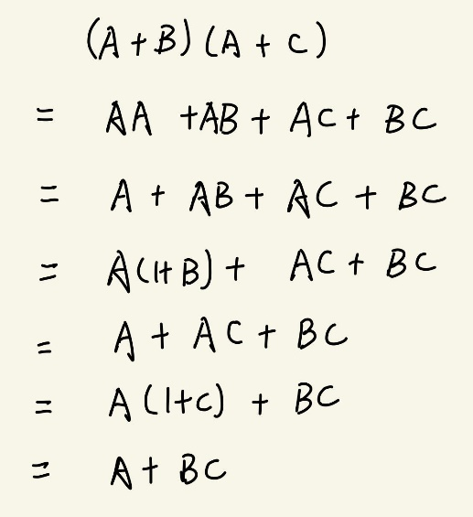 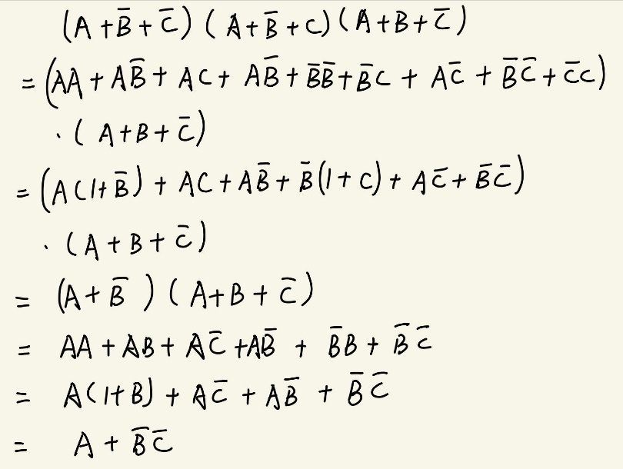

10. Perform following calculations with bitwise operators (consider the base) [1 point]

a) (0b1010 ⊕ 0b1001) ⊕ 0b1100

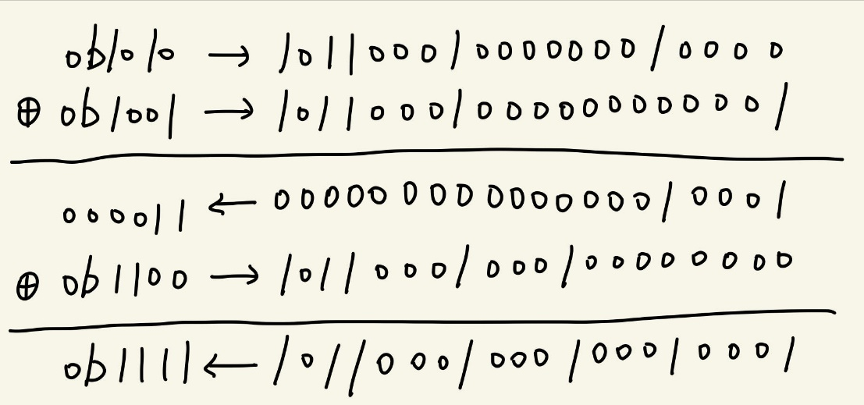

b) (0xA10 ^ 0xBA2) ∨ (0x57A)

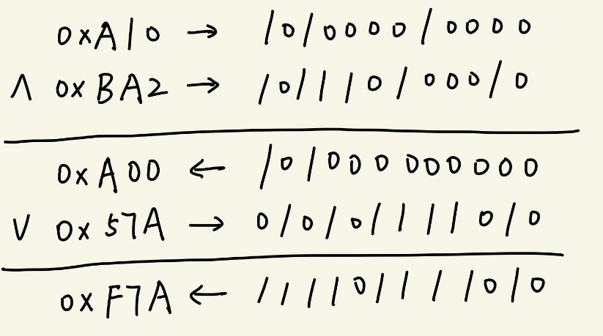

c) (0xA1 ^ 0xB6) ⊕ (0xC3 ∨ 0xD2)

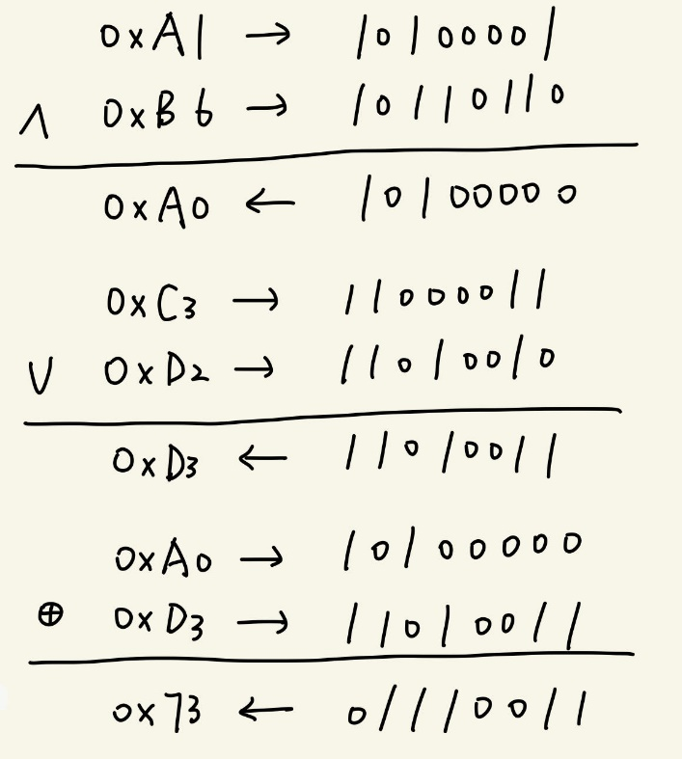

d) (￢0xA7) ∨(￢0xBD)

